Part 1A: Volume correction
Experiment 1A: Dynamic Function Tests
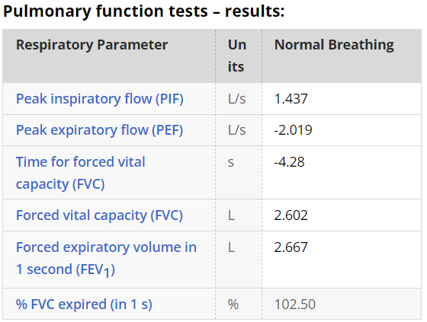
Experiment 1B: Obstructed airways
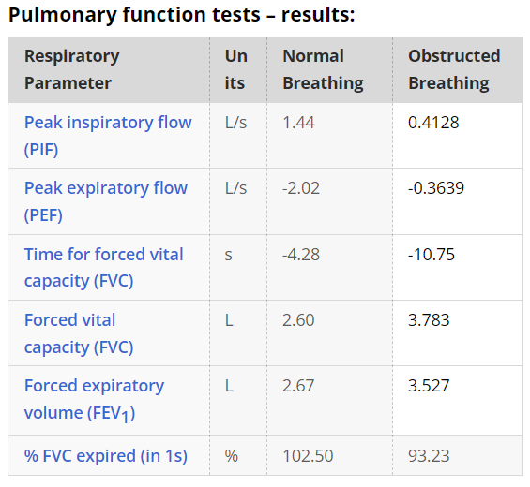

Experiment 2A: Static Measurements
